NAME: ANKIT KUMAR JHA REG.NO.20BPS1050

EXERCISE 5
Hyperledger fabric using IBM Blockchain platform

Downloading Prerequisites
- Visual Studio Code
- IBM Blockchain Platform extension

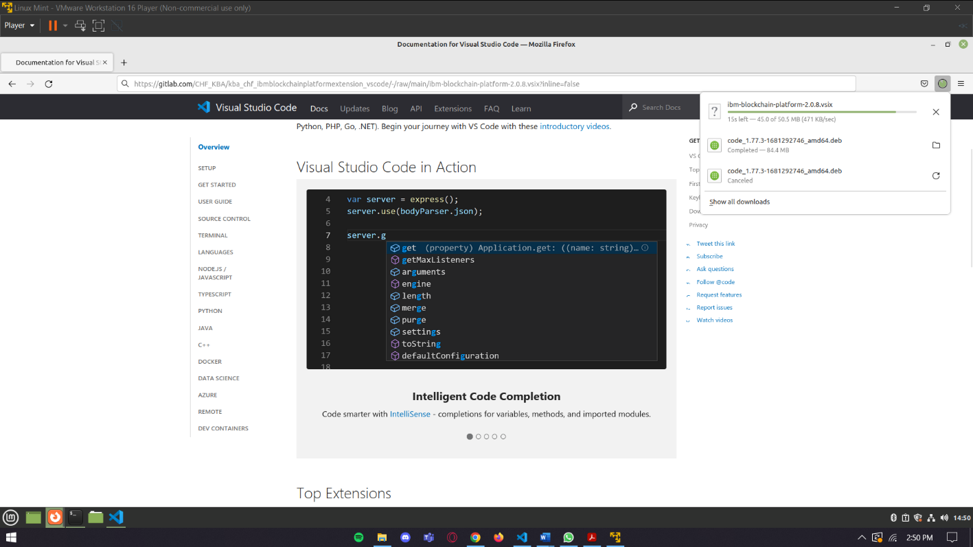

Installing Extension

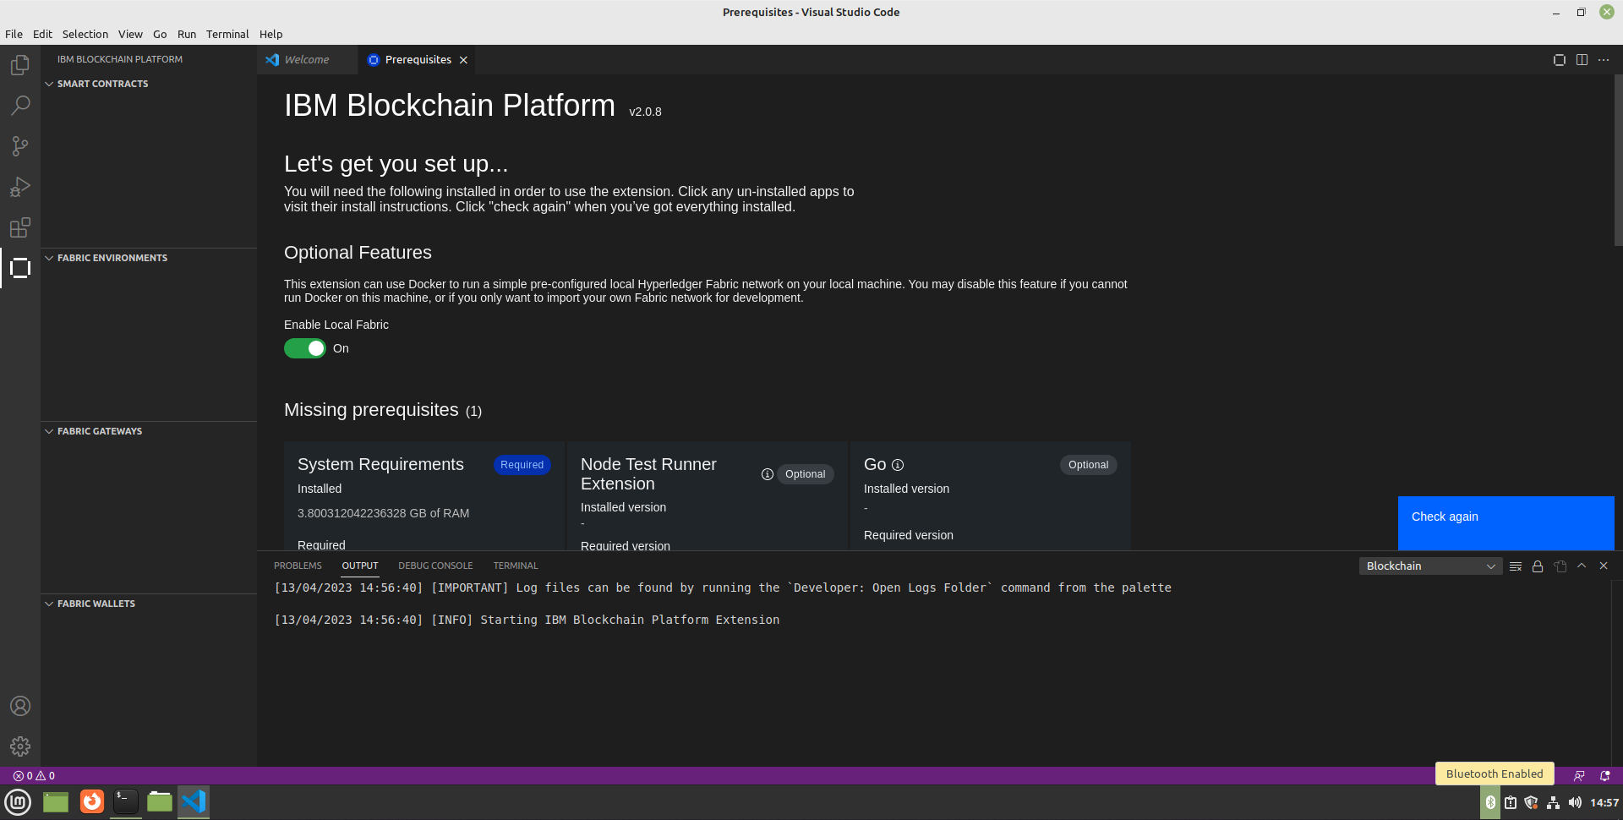

Configuration
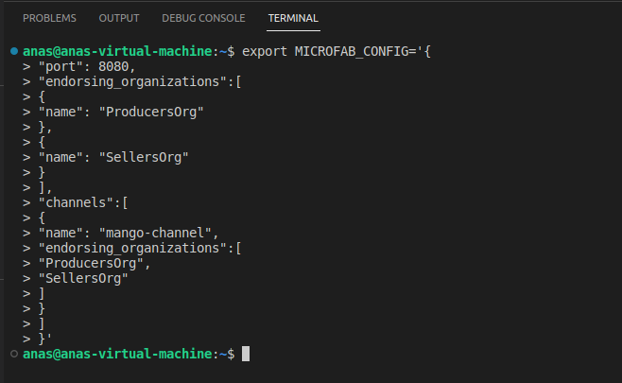

Running the Network
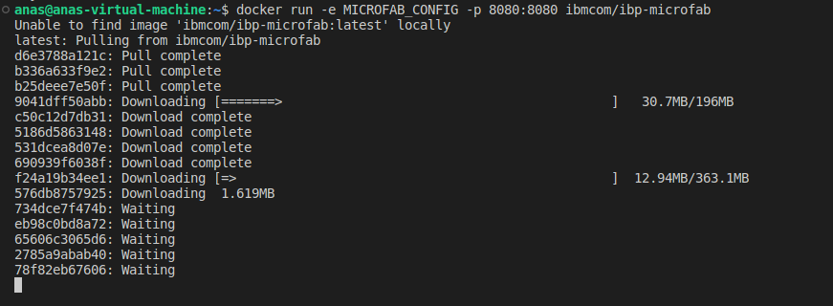

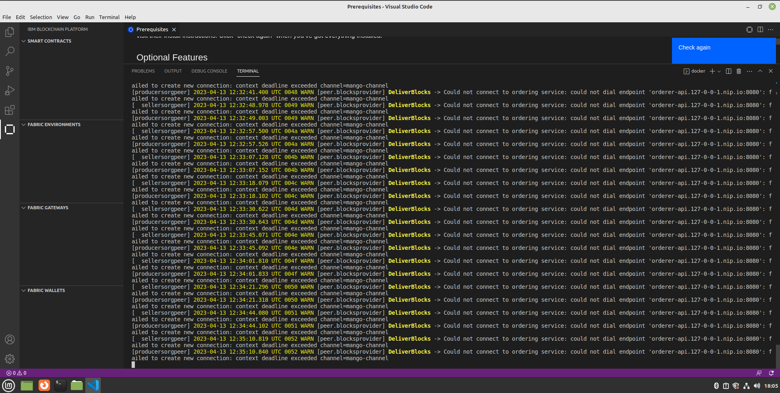

Smart Contract project
Package.json:

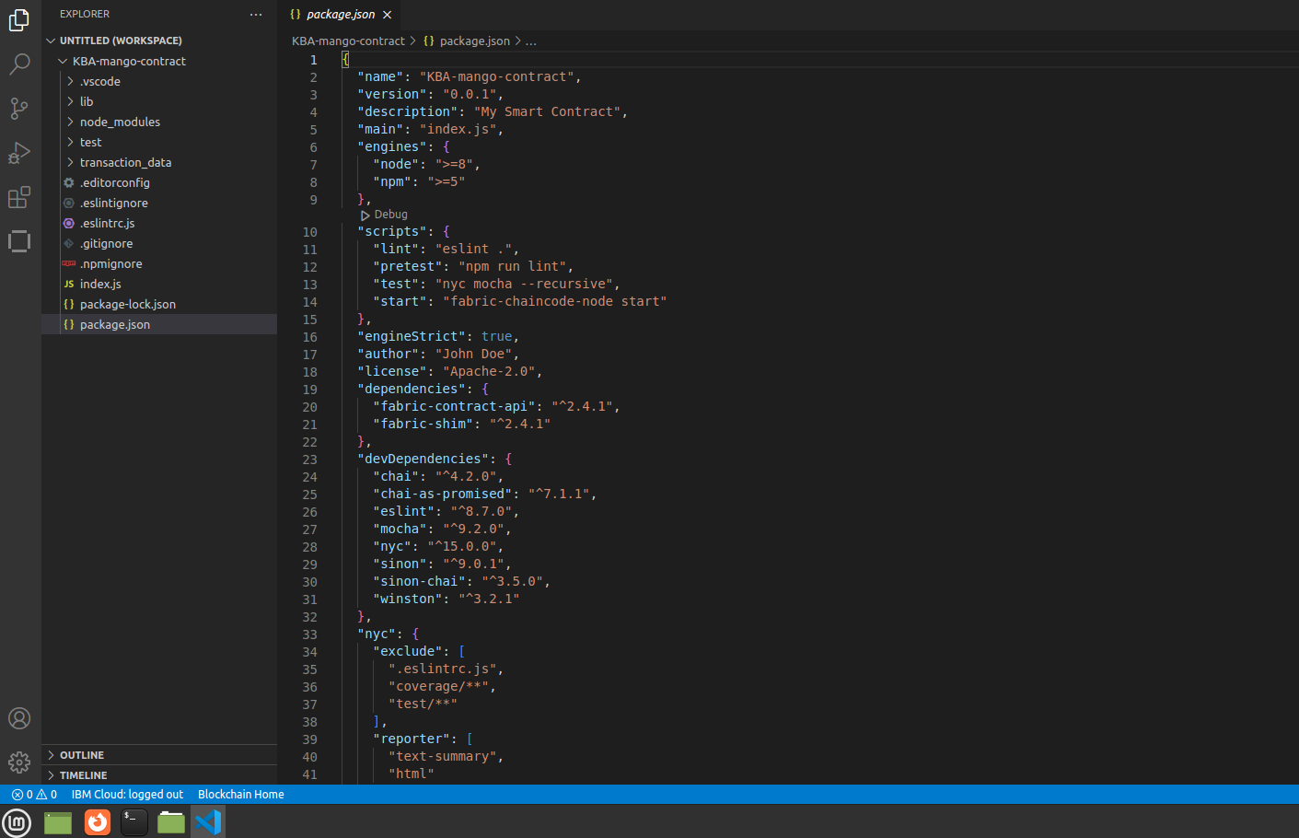

Index.js
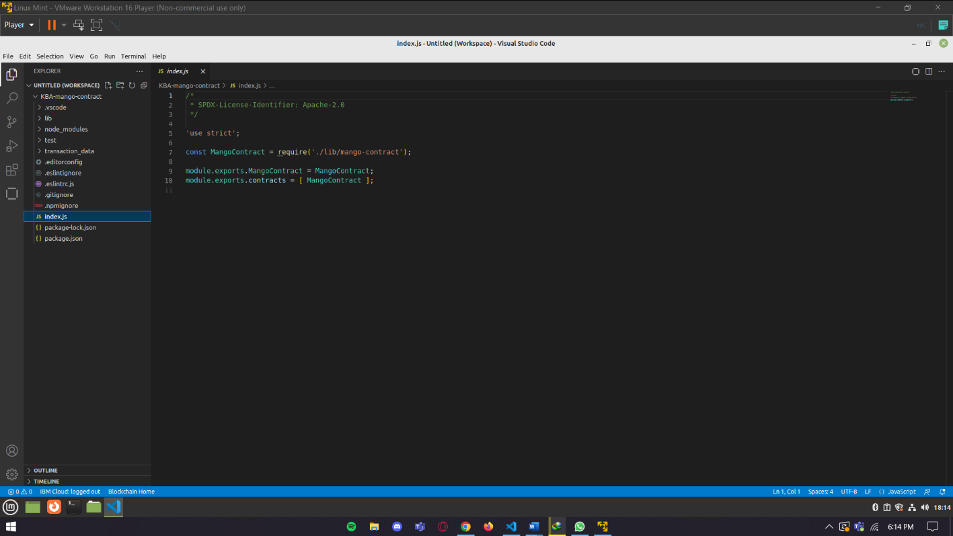

Mango-contract.js
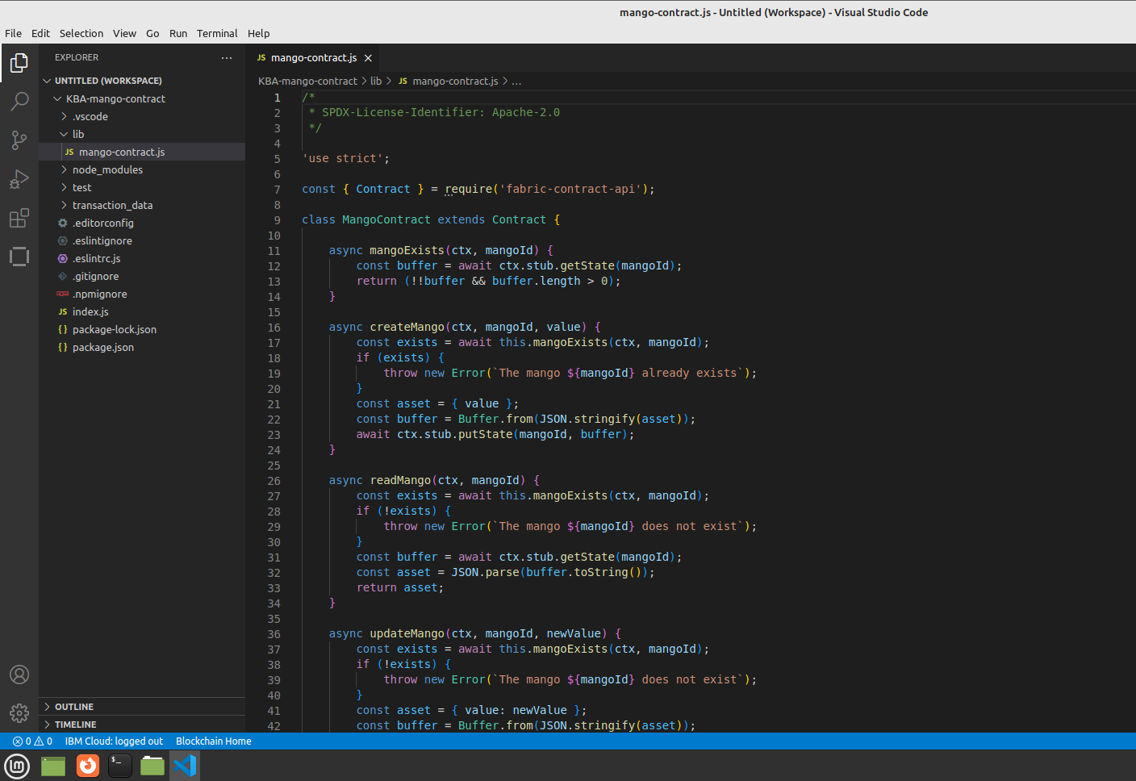

Adding More Functionalities
Mango-contract.js
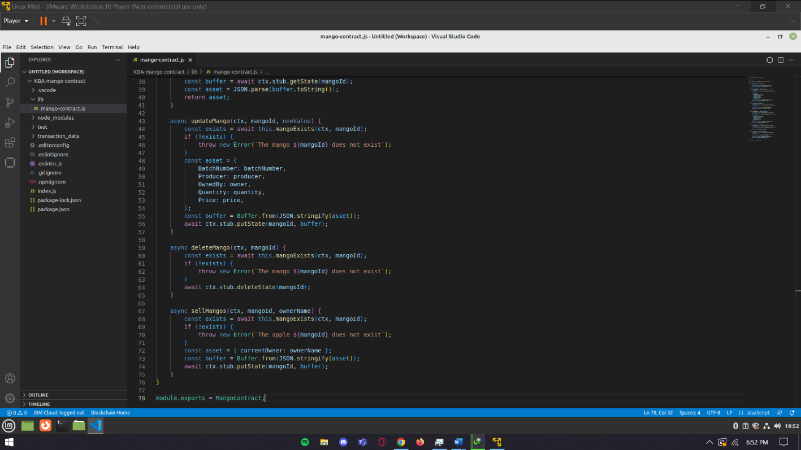

/*
* SPDX-License-Identifier: Apache-2.0
*/

'use strict';

const { Contract } = require('fabric-contract-api');

class MangoContract extends Contract {

async mangoExists(ctx, mangoId) {
const buffer = await ctx.stub.getState(mangoId);
return (!!buffer && buffer.length > 0);
}

async createMango(ctx, mangoId, value) {
const exists = await this.mangoExists(ctx, mangoId);
if (exists) {
throw new Error(`The mango ${mangoId} already exists`);
}
const asset = {
ID: mangoId,
BatchNumber: batchNumber,
Producer: producer,
OwnedBy: producer,
Quantity: quantity,
Price: price,
};
const buffer = Buffer.from(JSON.stringify(asset));
await ctx.stub.putState(mangoId, buffer);
}

async readMango(ctx, mangoId) {
const exists = await this.mangoExists(ctx, mangoId);
if (!exists) {
throw new Error(`The mango ${mangoId} does not exist`);
}
const buffer = await ctx.stub.getState(mangoId);
const asset = JSON.parse(buffer.toString());
return asset;
}

async updateMango(ctx, mangoId, newValue) {
const exists = await this.mangoExists(ctx, mangoId);
if (!exists) {
throw new Error(`The mango ${mangoId} does not exist`);
}
const asset = {

BatchNumber: batchNumber,

Producer: producer,
OwnedBy: owner,
Quantity: quantity,
Price: price,
};
const buffer = Buffer.from(JSON.stringify(asset));
await ctx.stub.putState(mangoId, buffer);
}

async deleteMango(ctx, mangoId) {
const exists = await this.mangoExists(ctx, mangoId);
if (!exists) {
throw new Error(`The mango ${mangoId} does not exist`);
}
await ctx.stub.deleteState(mangoId);
}

async sellMangos(ctx, mangoId, ownerName) {
const exists = await this.mangoExists(ctx, mangoId);
if (!exists) {
throw new Error(`The apple ${mangoId} does not exist`);
}
const asset = { currentOwner: ownerName };
const buffer = Buffer.from(JSON.stringify(asset));
await ctx.stub.putState(mangoId, buffer);
}
}

module.exports = MangoContract;

Packaging Smart Contract
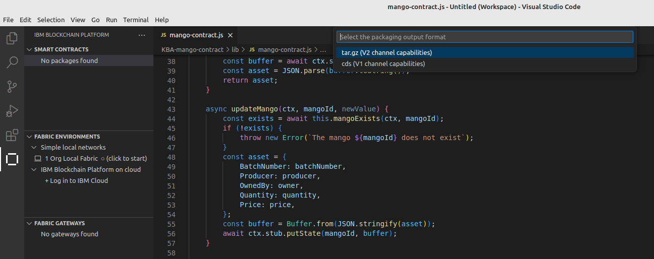

Fabric Environments

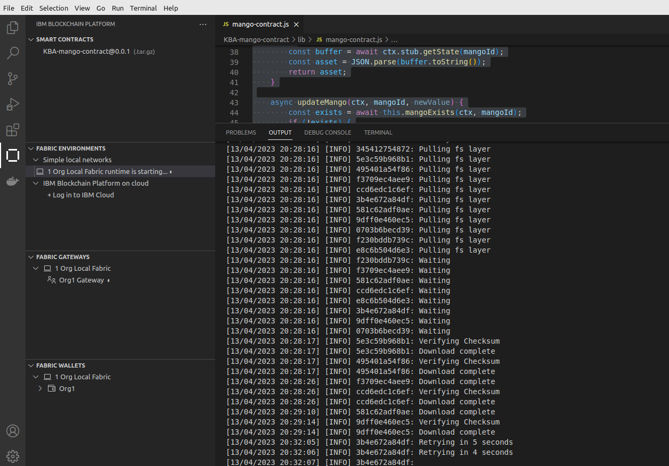

Deploy Smart Contract
Create Smart Contract Definition

Making Transactions
Fabric Gateway
mangoExists

createMango

readMango

